3 lbs. Breaded Colossal Shrimp

Ingredients: Shrimp, Wheat Flour, Water, Salt, White Corn Flour, Dextrose, Modified Corn Starch, Yeast, Leavening (Sodium Acid Pyrophosphate, Sodium Bicarbonate), Garlic Powder, Spices (Includes Celery Seed), Onion Powder, Citric Acid, Natural Flavor, Maltodextrin, Soybean Oil, Sodium Tripolyphosphate (Retains Moisture).
Contains: SHELLFISH (Shrimp), Wheat

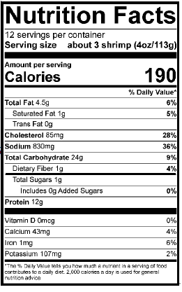

Preparation Instructions: Store shrimp in freezer. Cook shrimp from Frozen.
OVEN: Preheat oven to 425°F. Place breaded shrimp on wire rack set on top of baking sheet and cook for 15 – 18 minutes, or until shrimp are crisp outside and cooked throughout.
AIRFRYER: Using the Air fry function, preheat air fryer oven to 400°F for 10 minutes. Then, place shrimp into air fryer and cook 10 – 12 minutes, or until shrimp are crisp outside and cooked throughout. NOTE: COOKING TIMES MAY VARY ACCORDING TO APPLIANCE; ADJUST ACCORDINGLY.

